Case Lists
The BMC2 Coordinating Center will post case lists to Nextcloud (like reports). This list will contain the Hospital ID, Record ID, Gender, DOB, Procedure Type, admission date, procedure date, and DC date. Coordinators will be required to upload the redacted documentation for a maximum of six cases.

To retrieve your case list:
- Locate the email sent to you by "BMC2 Distribution". The email's subject line is BMC2 VSURG Peer Review - Site (your hospital ID).

Click on the link in the email. This link will take you to Nextcloud.

Open the reports folder.

Scroll down to the vsurg_peer_review folder and open it.

Open the 2026 folder.

Download the Excel spreadsheet.

Review the list of cases.

If you have questions or need assistance, please contact Rebecca at the Coordinating Center at (734) 328-4267.

2026 Dates to Remember
Case lists posted by 3/18/2026.
Case documentation upload deadline 4/20/2026.
Cross-site physician review 5/15/2026 - 5/29/2026.

Required Documentation

Each assigned case should include the documentation listed below. Your documents should be in the order of the documents in the list below. Combine the documents into one pdf file*. Name each file using VS_[the Record ID].pdf. For example, if the record ID# is 1234567. You will name the file VS_1234567.
Each pdf file will contain the documentation for the index procedure (the procedure on your case list) and subsequent procedure(s) related to the infection up to 5 months after the date of discharge:
Pre-operative Documentation
☐ | Pre-operative History & Physical (H&P)
Operative and Anesthesia Documentation
☐ | Operative report
☐ | Documentation of BMI at time of procedure
Discharge Documentation
☐ | Discharge Summary
Labs
☐ | Wound, blood, and urine cultures
☐ | C-reactive protein (CRP)
☐ | Pre-procedure A1c (within 4 months before the procedure)
Medication Documentation
☐ | Medication list if the medication list is not included in the H&P, ED notes, clinic notes, or discharge summary.
Emergency Department Documentation
☐ | Any Emergency Department notes related to the infection, up to 5 months after discharge of the index procedure if the patient was not readmitted.
Follow-up Documentation
☐ | All follow-up clinic notes, up to 5 months after discharge of the index procedure.

*The pdf should be as concise as possible and include the date of service.

File Redaction
The process for obtaining and redacting files will vary by site, depending on the protocols and procedures in place. If you are unfamiliar with your site's protocols, BMC2 recommends contacting your Health Information Management (HIM) or Medical Records department for assistance. If you have questions regarding the redaction of a piece of information, contact the Coordinating Center for clarification. Please read the redaction guidelines carefully. Failure to follow these guidelines could result in a deduction of P4P points.

Information to redact
  - PHI: Patient Name, MRN, SSN, address, full-face photograph, etc.
  - Geographic areas smaller than a state (city, township, street name, etc.)
  - Encounter number, FIN number, insurance plan.
  - References to the hospital or location of the procedure (hospital name, address, zip code, site logo)
  - Operator information or referring physician.
  - All employee names.
  - All phone numbers and fax numbers
  - Any information that could allow a reviewer to identify the patient, the hospital, or the physician
Do not redact the patient's DOB unless the patient is older than eighty-nine. Do not redact the date of service listed on the document.

Methods for redacting information
HIM/Medical Records Departments

The HIM/Med Records Departments at some sites will gather and redact the required information; however, the coordinator is responsible for communicating the information to redact to the HIM/Med Records Department.
- Coordinators are responsible for verifying that all necessary fields have been removed.
- Coordinators are still required to upload documents following the guidelines given by BMC2.

Adobe Acrobat Pro
Adobe Acrobat Pro has an easy-to-use redaction feature for redacting pdf information. This method is best to ensure that the reviewer cannot see the redacted information.

Using Adobe Acrobat Pro for Redaction:
- Sign in to your EMR.
- Epic users go to page 4 for instructions on remotely redacting a pdf.
  - This method may or may not be available for you based on the version of Epic at your hospital.
- Cerner users go to page 8 for instructions on remotely redacting a pdf.
Manual Redaction
- Whiteout tape/rollers (Next best method if Adobe Acrobat Pro is not accessible).

- Black marker (Sharpie, Magnum, Flipchart, etc.) You must copy the documents after redacting the information with a black marker before scanning the documents so that information will not show through the marker. The coordinating center will return the documents to the coordinator for correction, and P4P points will be deducted if the information shows through the black marker.

Whatever method you use for redaction, please have a co-worker double-check your redaction before uploading your file.

Uploading Case Files
After you have gathered and redacted the necessary case documentation and converted the documents to a pdf, the next step is to upload the files to the BMC2 Peer Review Uploader website. Uploading all documentation to the BMC2 Peer Review Uploader website is required. Notify Rebecca Fleckenstein at the BMC2 Coordinating Center via email when all files are uploaded.
The coordinating center staff will review the documents for completeness after they are submitted. Coordinators will be notified via email when their cases have been reviewed and the next steps they should take.

Uploading Case Files to the BMC2 Peer Review Uploader Website

- Go to the BMC2 Peer Review Uploader website using Chrome, Firefox, or Microsoft Edge. Do not use Internet Explorer. You will not be able to upload files using Internet Explorer.  - Enter your site number in the Identifier field.  - Select See Case Lists. | 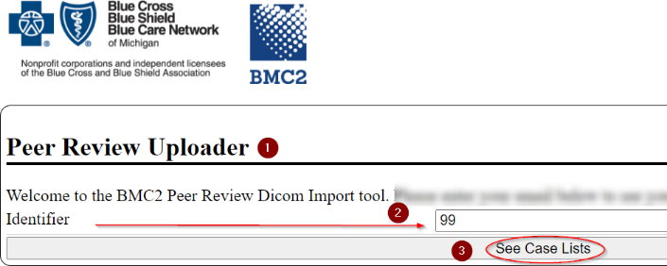
- A list of Record ID#s will display. Locate the Record ID# under the Case column.  - Click on the pdf icon that corresponds to the Record ID. The pdf icon is on the right side of the screen. | 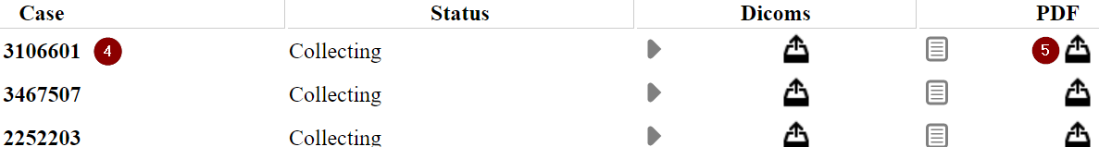
- The Upload PDF screen will display. Click on the Choose Files button. | 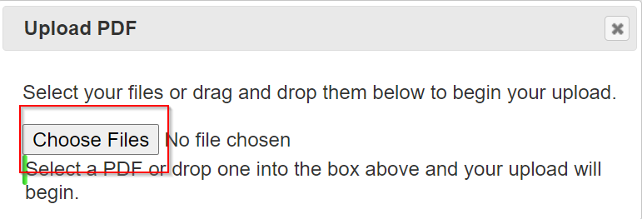
- Locate where your file is on your computer.  - Click on the file.  - Select the Open button. | 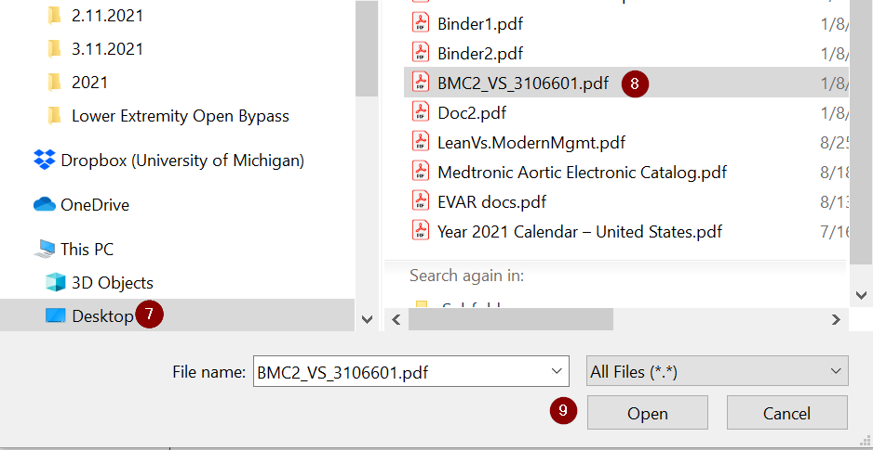
- You will see the Upload PDF box again. You know that your file is being uploaded when you see the green bar and the word "Processed."  - Click on the X on the top right corner of the screen. | 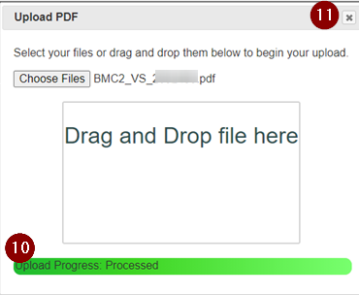
- Click on the reload icon to refresh the page.
- The pdf icon is now black instead of grey. Click on that icon to the left of the pdf tray icon to review the file you uploaded. | 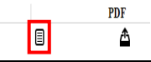
- You can now upload another file if applicable.

How to remotely redact a pdf for Epic users
- Select the patient in Epic. Go to Chart Review.
- Click on the Encounters or Notes tab and double-click the Admission (Discharge) encounter. Click on the printer icon located at the top left side of the note. | 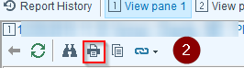
- The Choose Attachments to Print box will display.  - Click on the box under the Print column for each document you want in your pdf.  - Select Continue. | 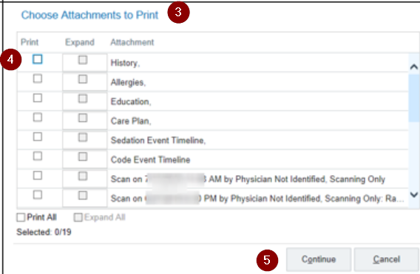
- The Print box will display. Select Adobe PDF.  - Select Print. | 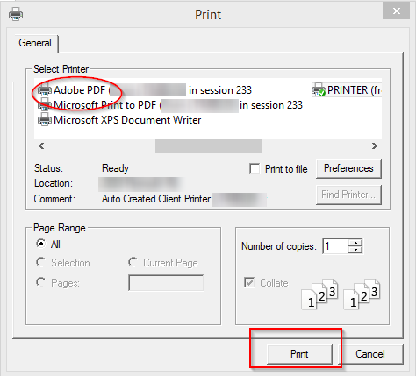
- The Save PDF File As box will display. Save the pdf to your computer. You do not need to rename the file at this time. | 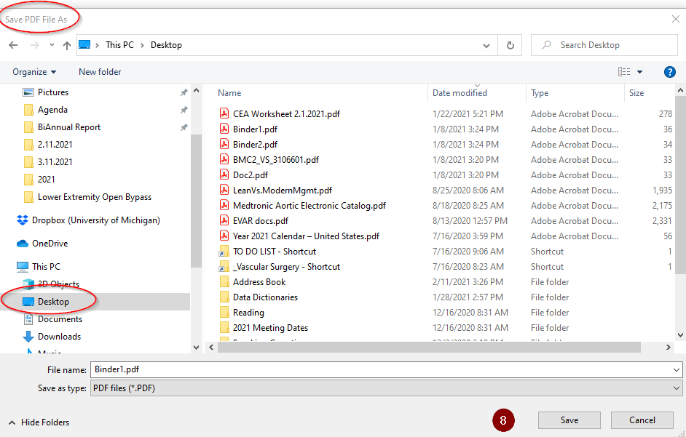
- Open the pdf on your computer if it does not open. Select Tools on the top left of the page. Scroll down and choose the Redact icon. | 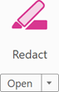
- You will see the document again. Click on the arrow next to Redact Text & Images at the top center of the page.  - Select Find Text & Redact.  - Select OK. | 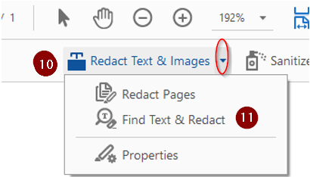
- A box will display. Type in the word or phrase you want to redact in the What word or phrase would you like to search for? field. For example, type in Smith, Jim.  - Click on the Search and Remove Text button. | 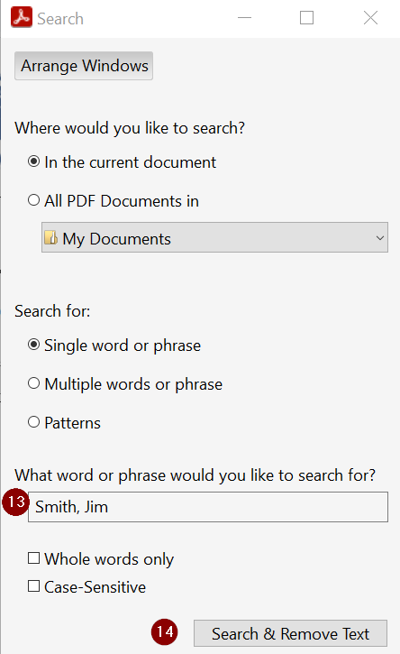
- Select Check All.  - Select Mark Select Results for Redaction.  Repeat Steps 11 – 16 until all required data are redacted.  - When you have redacted all required data, close the window. | 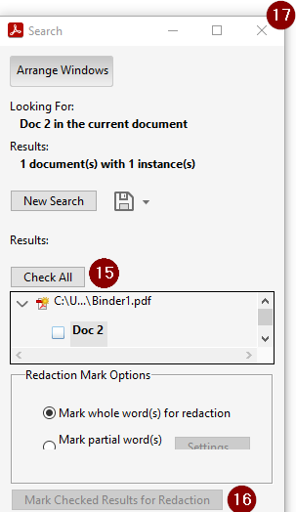
- Scroll through the document to make sure that all data are redacted. If you find an item that needs to be redacted, click on the Redact icon on the page's right-hand side. Highlight the data you want to redact. A black box will appear over the data that you highlighted.
- Click Sanitize Document at the top center of the page.  - Click OK. | 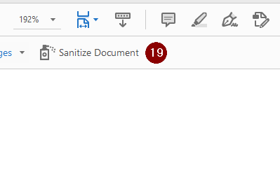
- The Save PDF File As box will display. Type VS_[the Record ID] in the File name field. Save the pdf to your computer. | 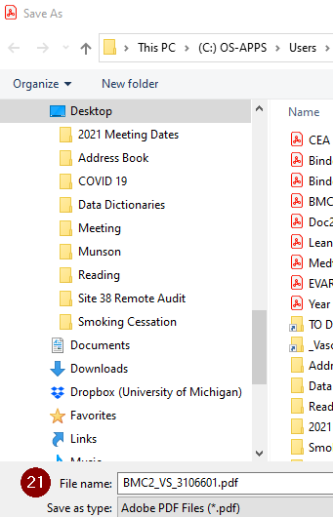
- You will see the open pdf. Click the Close button on the top right side of the pdf. Close the pdf. | 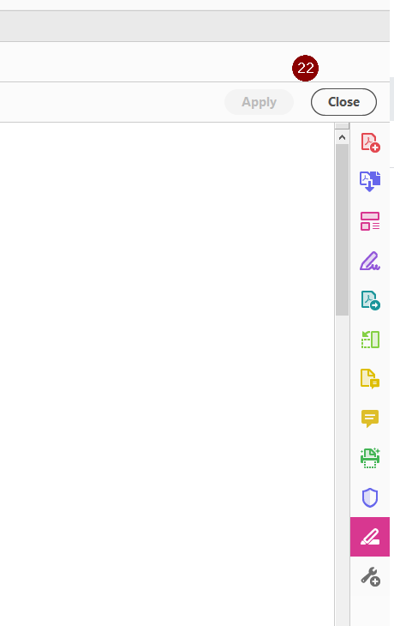

How to remotely redact a pdf for Cerner users
  - Select the patient in Cerner.
  - Open the document you want to save as a pdf.
  - Right-click on the document. Select Print.

- The Print box will display. Select Adobe PDF.  - Select Print.  - Click on Continue. | 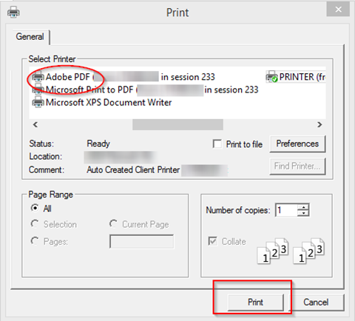
- The Save PDF File As box will display. Save the pdf to your computer. Rename your file so that you know what type of document it is. For example, rename your file H&P. | 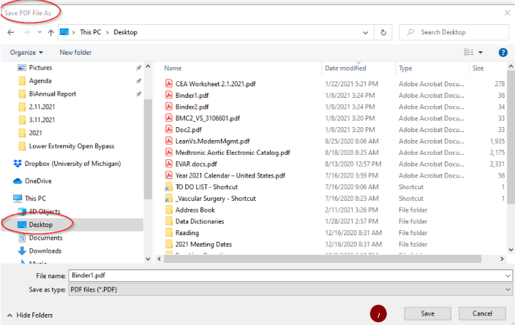
  - Repeat steps 2 – 7 until you save all required documents on your computer.
  - Open one of the pdfs that you saved to your computer.
- Select Tools on the top left of the page. Scroll down and choose the Combine Files icon. | 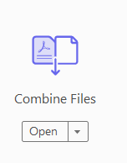
- Select Add Files. | 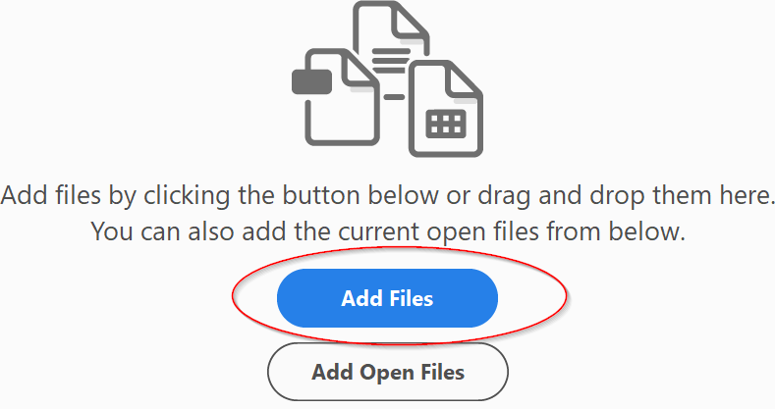
- The Add Files box will display. Find the pdf you just opened on your computer. Click on the file once. You will see the name of the file in the File Name box. Select Open. | 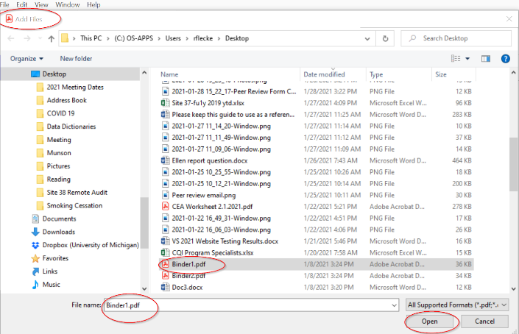
- Select Add Files at the top of the page.  - Select + Add Files. | 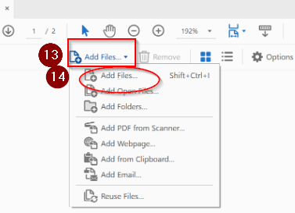
- The Add Files box will display again. Find another pdf that you saved on your computer.  - Select Open. | 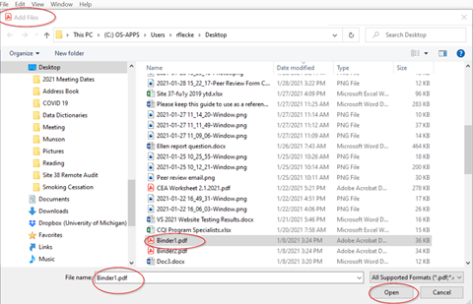
  - Repeat Steps 13 – 16 until you have added all the documents you saved on your computer.

- Select the Combine button at the top right side of the page. You have now combined all your separate pdfs into one pdf. | 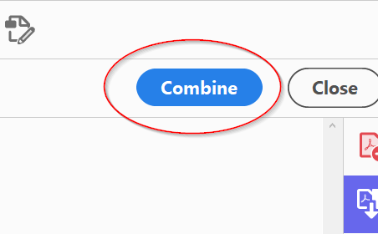
  - Select Tools on the top left of the page. Scroll down and choose the Redact icon.
- You will see the document again. Click on the arrow next to Redact Text & Images at the top center of the page.  - Select Find Text & Redact.  - Select OK. | 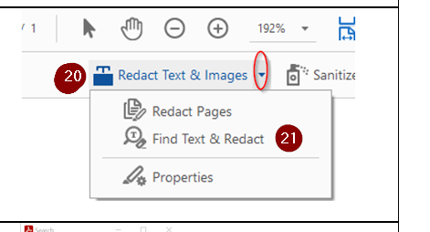
- A box will display. Type in the word or phrase you want to redact in the What word or phrase would you like to search for? field. For example, type in Smith, Jim.  - Click on the Search & Remove Text button. | 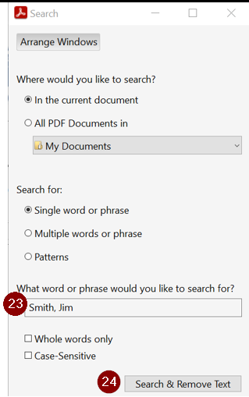
- Select Check All.  - Select Mark Checked Results for Redaction.  Repeat Steps 21 - 26 until all required data are redacted.  - When you have redacted all required data, close the window. | 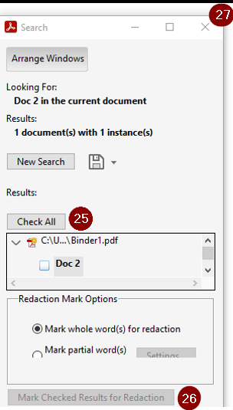
  - Scroll through the document to make sure that all data is redacted. If you find an item that needs to be redacted, click on the Redact icon on the page's right-hand side. Highlight the data you want to redact. A black box will appear over the data that you highlighted.

- Click Sanitize Document at the top center of the page.  - Click OK. | 
- The Save As box will display. Type VS_[the Record ID] in the File name field. Save the pdf to your computer. | 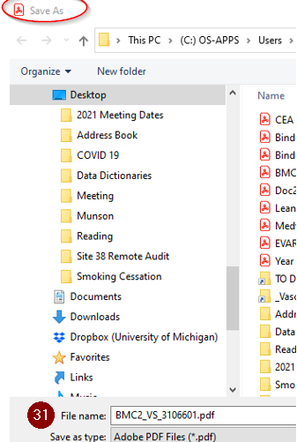
- You will see the open pdf. Click the Close button on the top right side of the pdf. Close the pdf. | 