WIfI Classification System: Wound, Ischemia, Foot Infection
Wound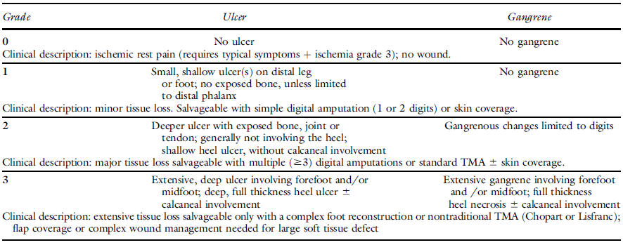
Ischemia
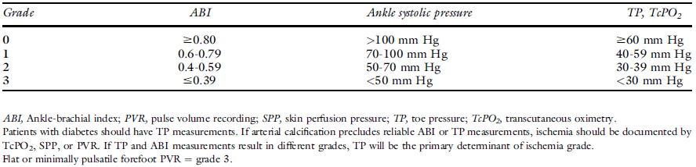
Foot Infection
